County Level Income and Health Data Workflow

Zhirui Wang
Udacity Master of AI
AI Programming Foundations Project
03/01/2026

Abstract
This project created a complete, reproducible data workflow to examine the relationship between U.S. county-level socioeconomic conditions and health outcomes. The workflow combined CDC PLACES 2024 county health estimates with American Community Survey (ACS) 5-year median household income (B19013) by joining on county FIPS codes, then cleaned, explored, and visualized the merged data.

Key findings include a negative association between county median income and prevalences of obesity and diabetes, and positive correlations among the selected health outcomes. The workflow is documented and version-controlled to serve as a foundation for future machine learning or AI projects.
Detailed Description of the Dataset
The analysis used two datasets:
- CDC PLACES (county file)
One row per county per measure. Key columns: state and location names, LocationID (county FIPS), MeasureId (e.g., OBESITY, DIABETES), Data_Value (prevalence %), and data type (crude or age-adjusted).
- ACS B19013
One row per county. Key columns: GEO_ID (from which 5-digit county FIPS was extracted), NAME, and B19013_001E (median household income in 2024 dollars).
The unique identifier for merging is the 5-digit county FIPS code. The final merged dataset includes median household income and prevalence percentages for obesity, diabetes, high blood pressure, depression, and arthritis.

Workflow Description
The workflow followed a linear pipeline:
- Importing — NumPy, Pandas, Matplotlib, and Seaborn were imported; project paths and a random seed were set; PLACES and ACS CSV files were loaded with dedicated functions and first rows displayed.
- Cleaning — County FIPS was standardized to 5-character strings (including extraction from ACS GEO_ID); numeric columns were coerced with suppressed/missing markers treated as NA; PLACES was filtered to five measures and pivoted to one row per county.
- Exploratory analysis — An EDA function computed shape, missingness, summary statistics, top and bottom counties by income, and a correlation matrix.
- Feature engineering — Log-income and income quartiles were derived.
- Visualizations — Three figures: scatter (income vs. obesity) with trend line, boxplot (diabetes by income quartile), and correlation heatmap (income and health measures).
- Summaries — Narrative summary and interpretation were written in the notebook; merged dataset and figures were saved to disk.

Key Decisions and Assumptions
Cleaning choices
- County FIPS was standardized to 5-digit strings and rows with invalid or missing FIPS were dropped so PLACES and ACS could be joined reliably.
- Data value columns were coerced to numeric; Census/PLACES suppression symbols (e.g., “-”, “N”, “(X)”) were treated as missing; counties with missing median income were dropped.
- These steps avoid join failures and invalid arithmetic but may exclude suppressed counties and introduce selection bias.
What was focused on
- Five health measures (obesity, diabetes, high blood pressure, depression, arthritis) that are well-documented and linked to socioeconomic status.
- Inner join so results include only counties present in both sources.
What was not focused on
- No adjustment for confounders (e.g., age, race, rurality).
- Margins of error were not used in visualizations.
- No analysis of time trends or state-specific patterns.

Results and Interpretation
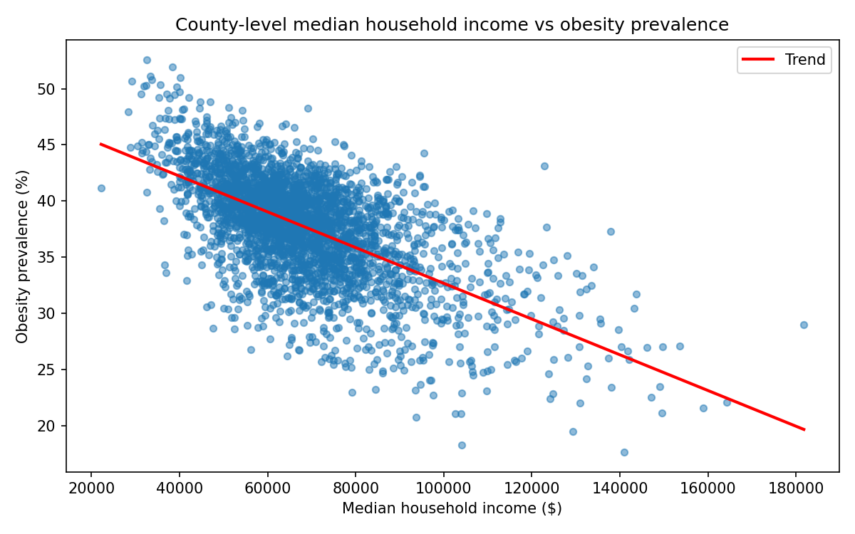Figure 1 (Scatter: income vs. obesity)
As county median household income increases, obesity prevalence tends to decrease, with a clear negative trend. Considerable scatter around the line indicates that income alone does not fully explain county-level obesity.
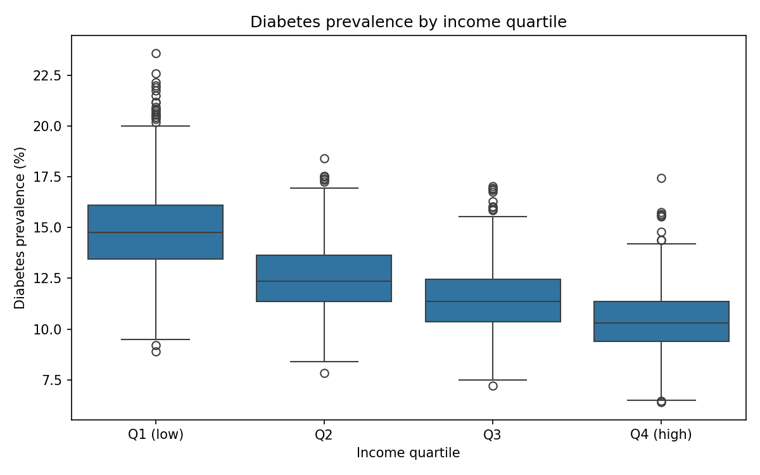Figure 2 (Boxplot: diabetes by income quartile)
Diabetes prevalence is higher in the lowest income quartile (Q1) and lower in the highest (Q4), with a graded pattern across quartiles.
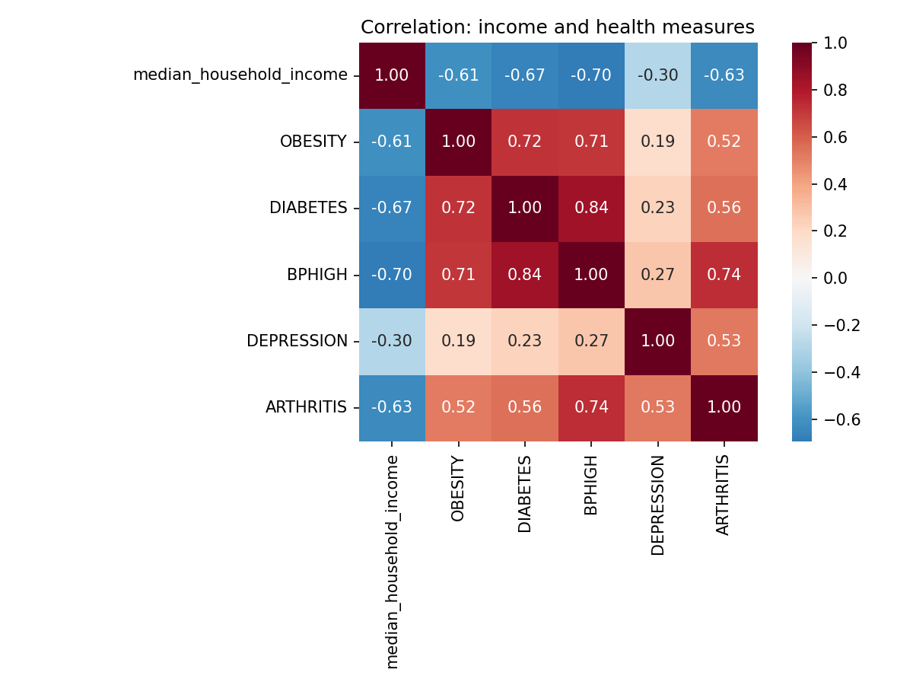Figure 3 (Correlation heatmap)
Median household income is negatively correlated with each of the five health outcomes; the health outcomes are positively correlated with one another.
Together, these results are consistent with a county-level socioeconomic gradient in health and with multiple health conditions co-occurring at the county level.

Responsible Practice (Bias and Data Quality)
- Transparency — Cleaning choices were documented so that dropping invalid FIPS or suppressed values is explicit; this highlights the risk of selection bias where missingness may be higher in smaller or disadvantaged counties.
- Ecological fallacy — The notebook and README state that county-level associations cannot be interpreted as individual-level causation.
- Data quality — PLACES estimates are model-based and ACS estimates have margins of error; neither was used to make causal claims.
- Bias awareness — The README includes a “Bias awareness” section on how poor or selective cleaning could introduce bias and how ecological inference limits interpretation.
Reproducibility
The project follows principles of reproducible computational research (Sandve et al., 2013; Danchev, 2022).
- Codebase — The repository contains data_workflow.ipynb and a src/ package (config, ingestion, cleaning, EDA, visualization).
- Dependencies — Listed in requirements.txt; users run pip install -r requirements.txt in a virtual environment.
- Execution — The notebook is run from the project root so paths and the src package resolve correctly.
- Data — Raw files (PLACES CSV and ACS B19013 folder) go under Data/Raw/ as in the README.
- Random seed — A fixed seed is set in the notebook.
- Outputs — Processed data and figures are written to Data/processed/ and outputs/figures/.

References
American Community Survey. (n.d.). U.S. Census Bureau. https://www.census.gov/programs-surveys/acs
Centers for Disease Control and Prevention. (2024). PLACES: Local data for better health—County data 2024 release. https://www.cdc.gov/places
Danchev, V. (2022). Reproducible data science with Python: An open learning resource. Journal of Open Source Education, 5(56), Article 156. https://doi.org/10.21105/jose.00156
Hunter, J. D. (2007). Matplotlib: A 2D graphics environment. Computing in Science & Engineering, 9(3), 90–95. https://doi.org/10.1109/MCSE.2007.55
McKinney, W. (2011). pandas: A foundational Python library for data analysis and statistics. Python for High Performance and Scientific Computing, 14(9), 1–9.
Sandve, G. K., Nekrutenko, A., Taylor, J., & Hovig, E. (2013). Ten simple rules for reproducible computational research. PLoS Computational Biology, 9(10), e1003285. https://doi.org/10.1371/journal.pcbi.1003285
Subramanian, S. V., & Kawachi, I. (2004). Income inequality and health: What have we learned so far? Epidemiologic Reviews, 26(1), 78–91. https://doi.org/10.1093/epirev/mxh003

